Lab3 Solution
Suppose you need to store the following order in the database:
Ordernumber:122435
Orderdate 11/09/2021
Customer name: Frank Brown
Customer email: fbrown@gmail.com
Customer phone: 0623156543
Total price : 5160.00
quantity | Product number | Product name | price
2 | A546 | IPhone 12 | 980.00
4 | S333 | Samsung Galaxy 12S | 800.00

1. Draw the tables including data that you need to store this order in a relational database.

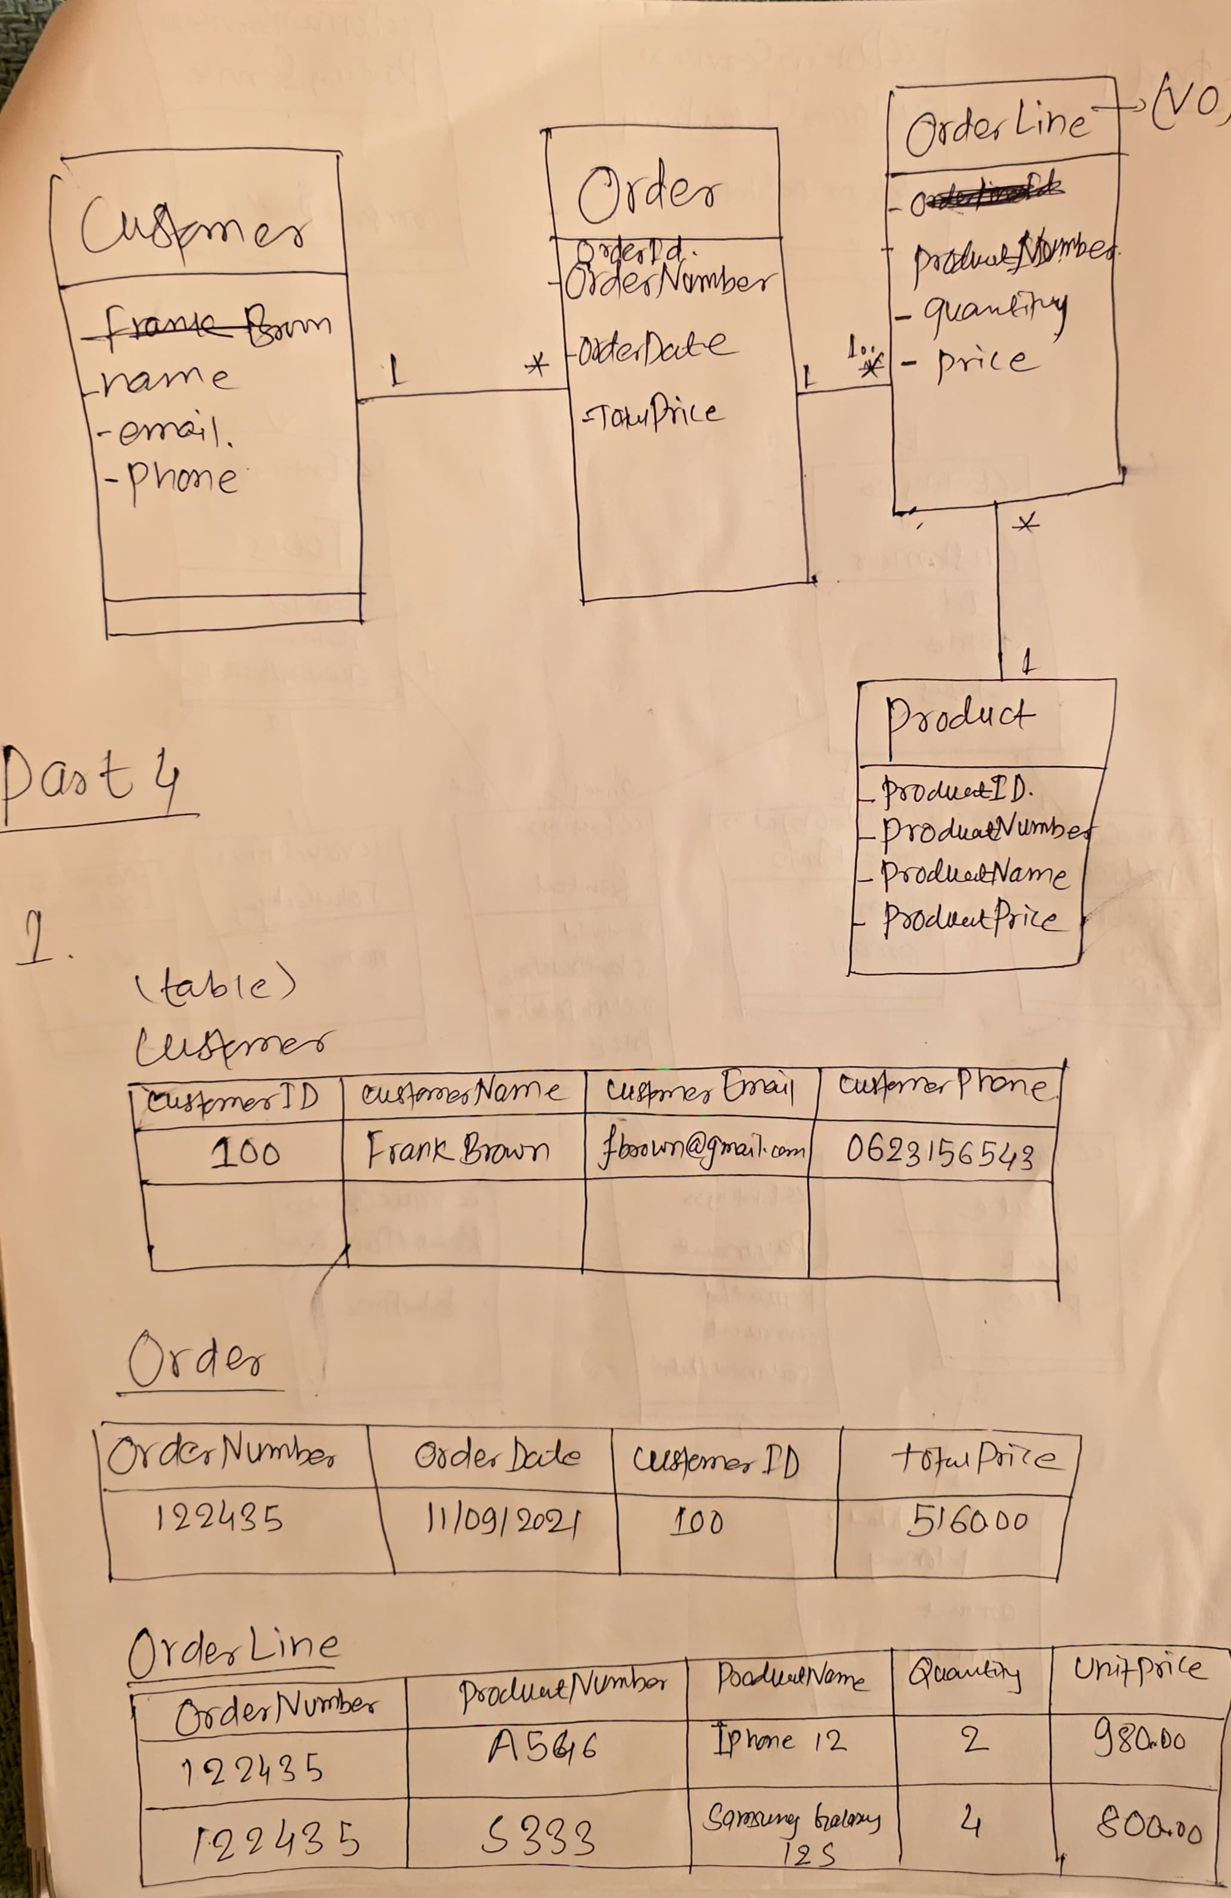

2. Draw the collections including data that you need to store this order in a mongo database.

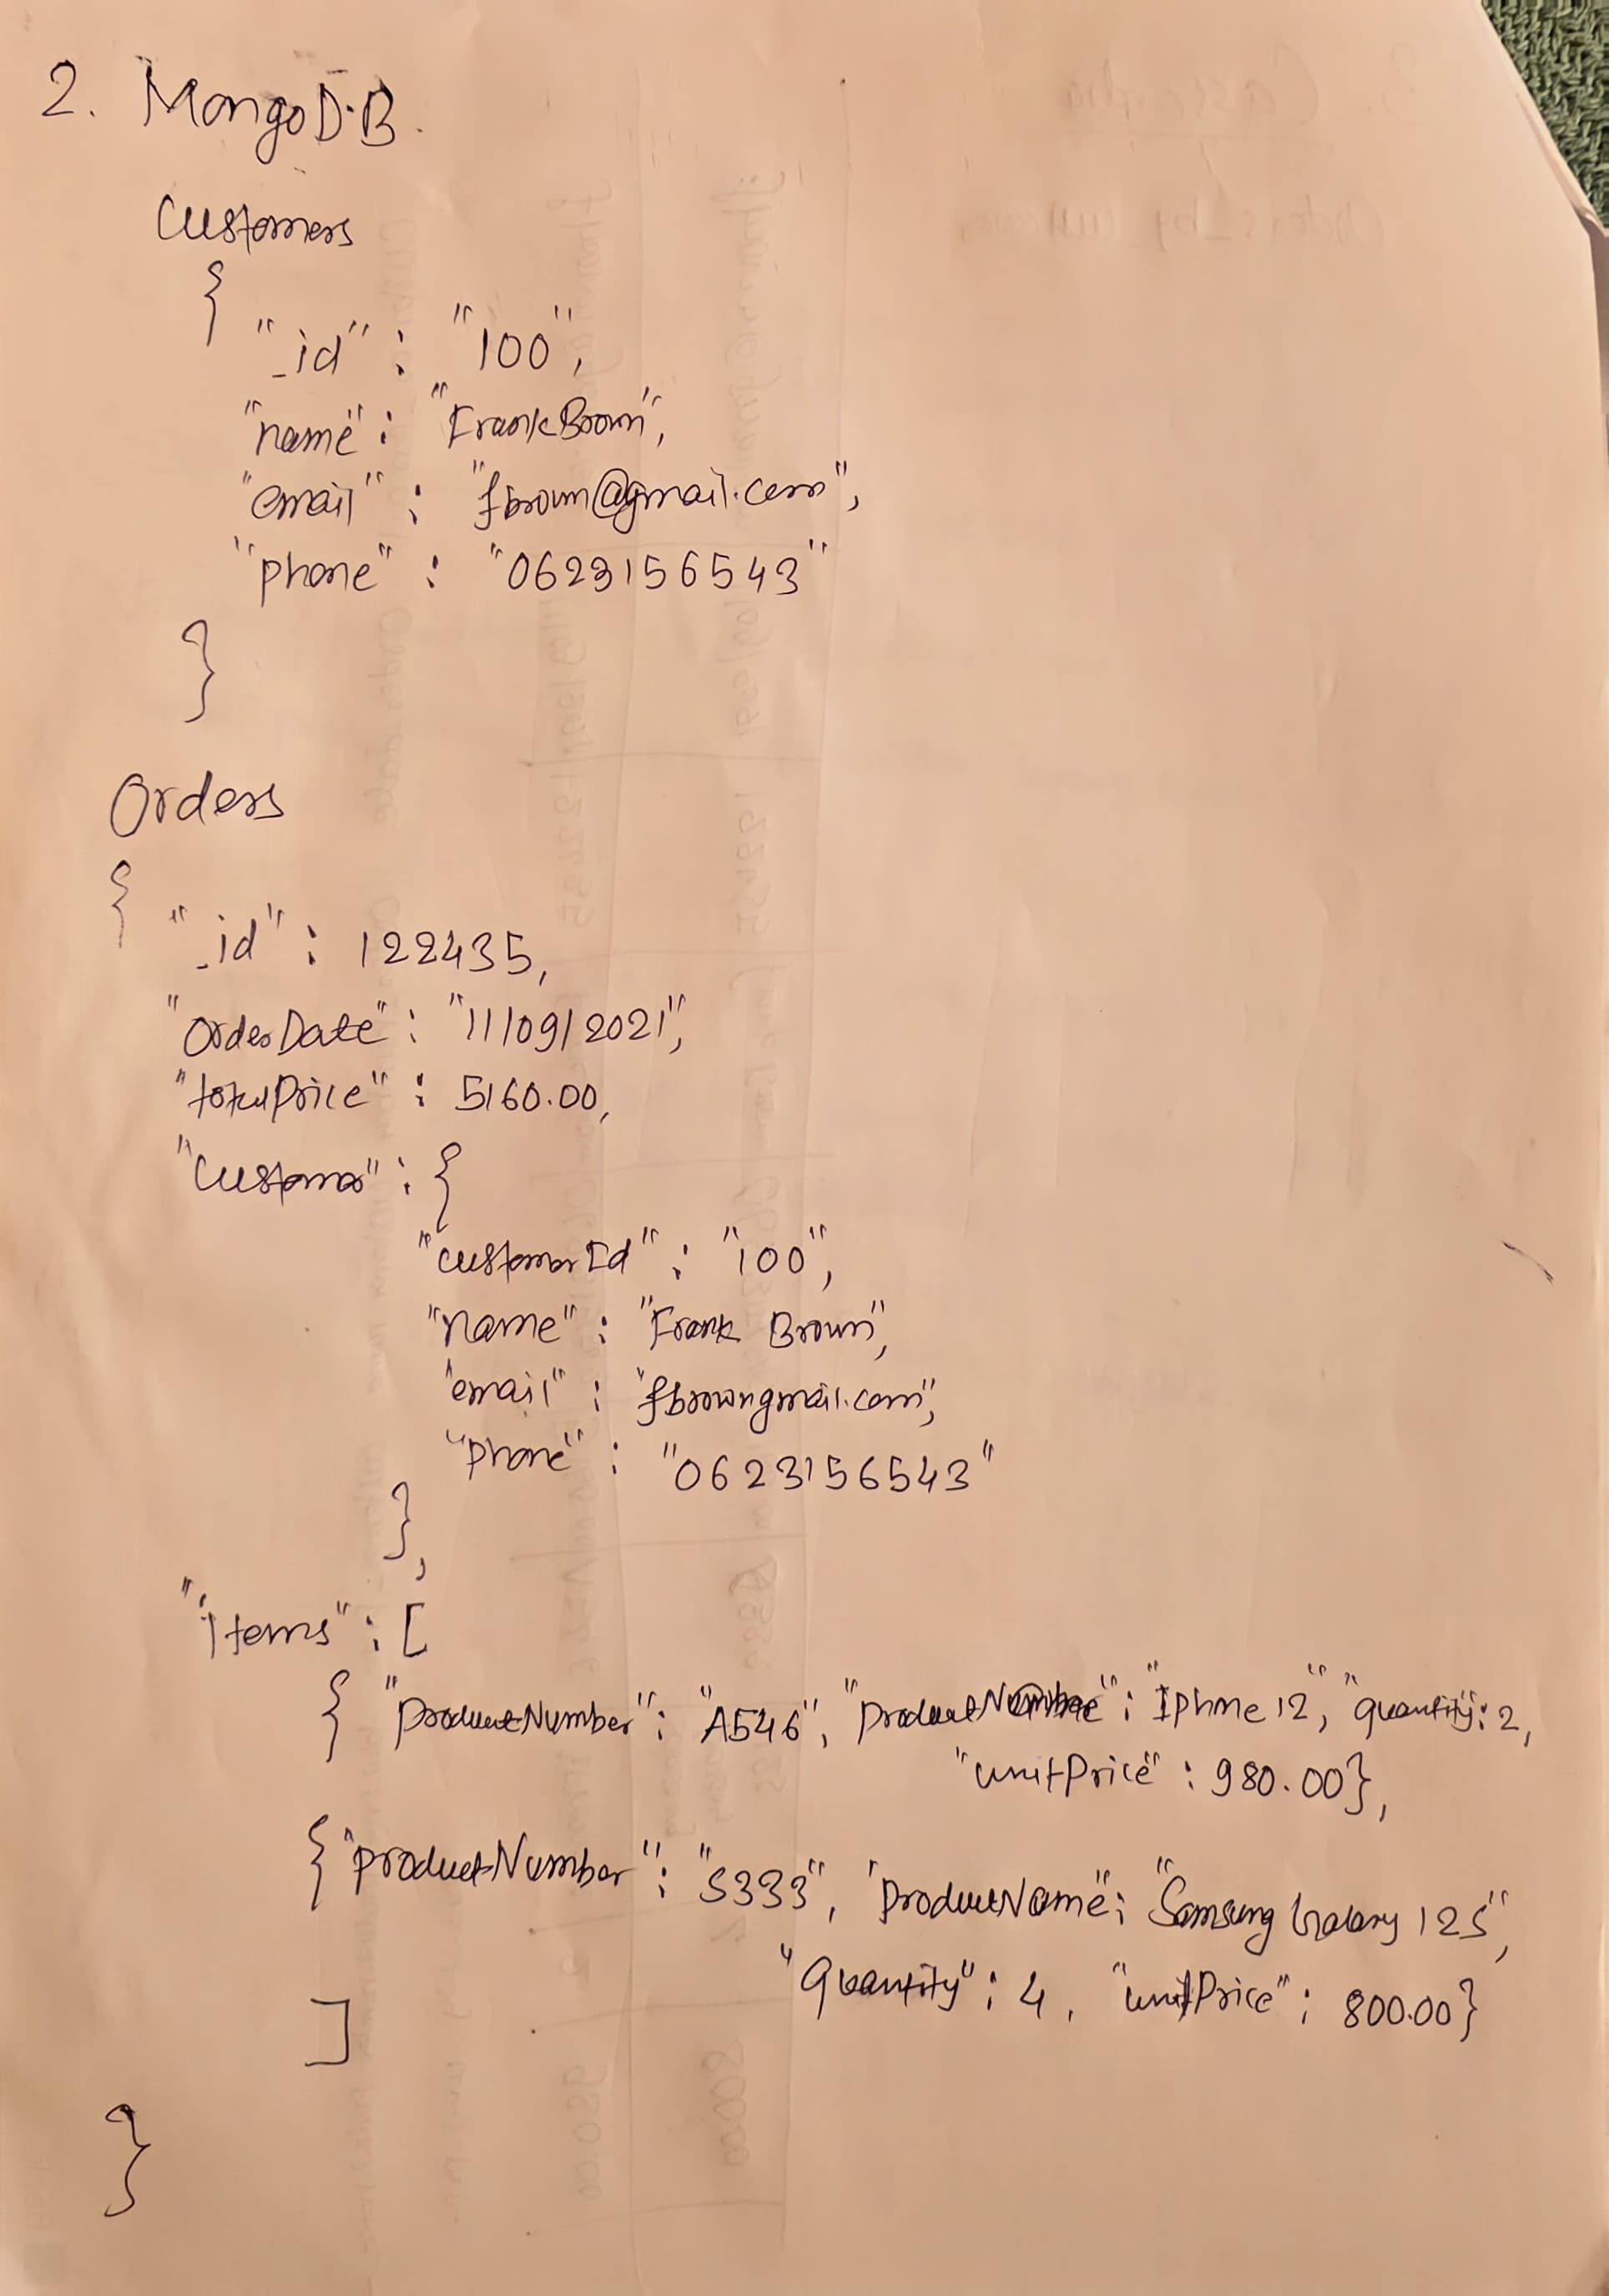

3. Draw the tables including data that you need to store this order in a cassandra database if you are interested in orders by customer.

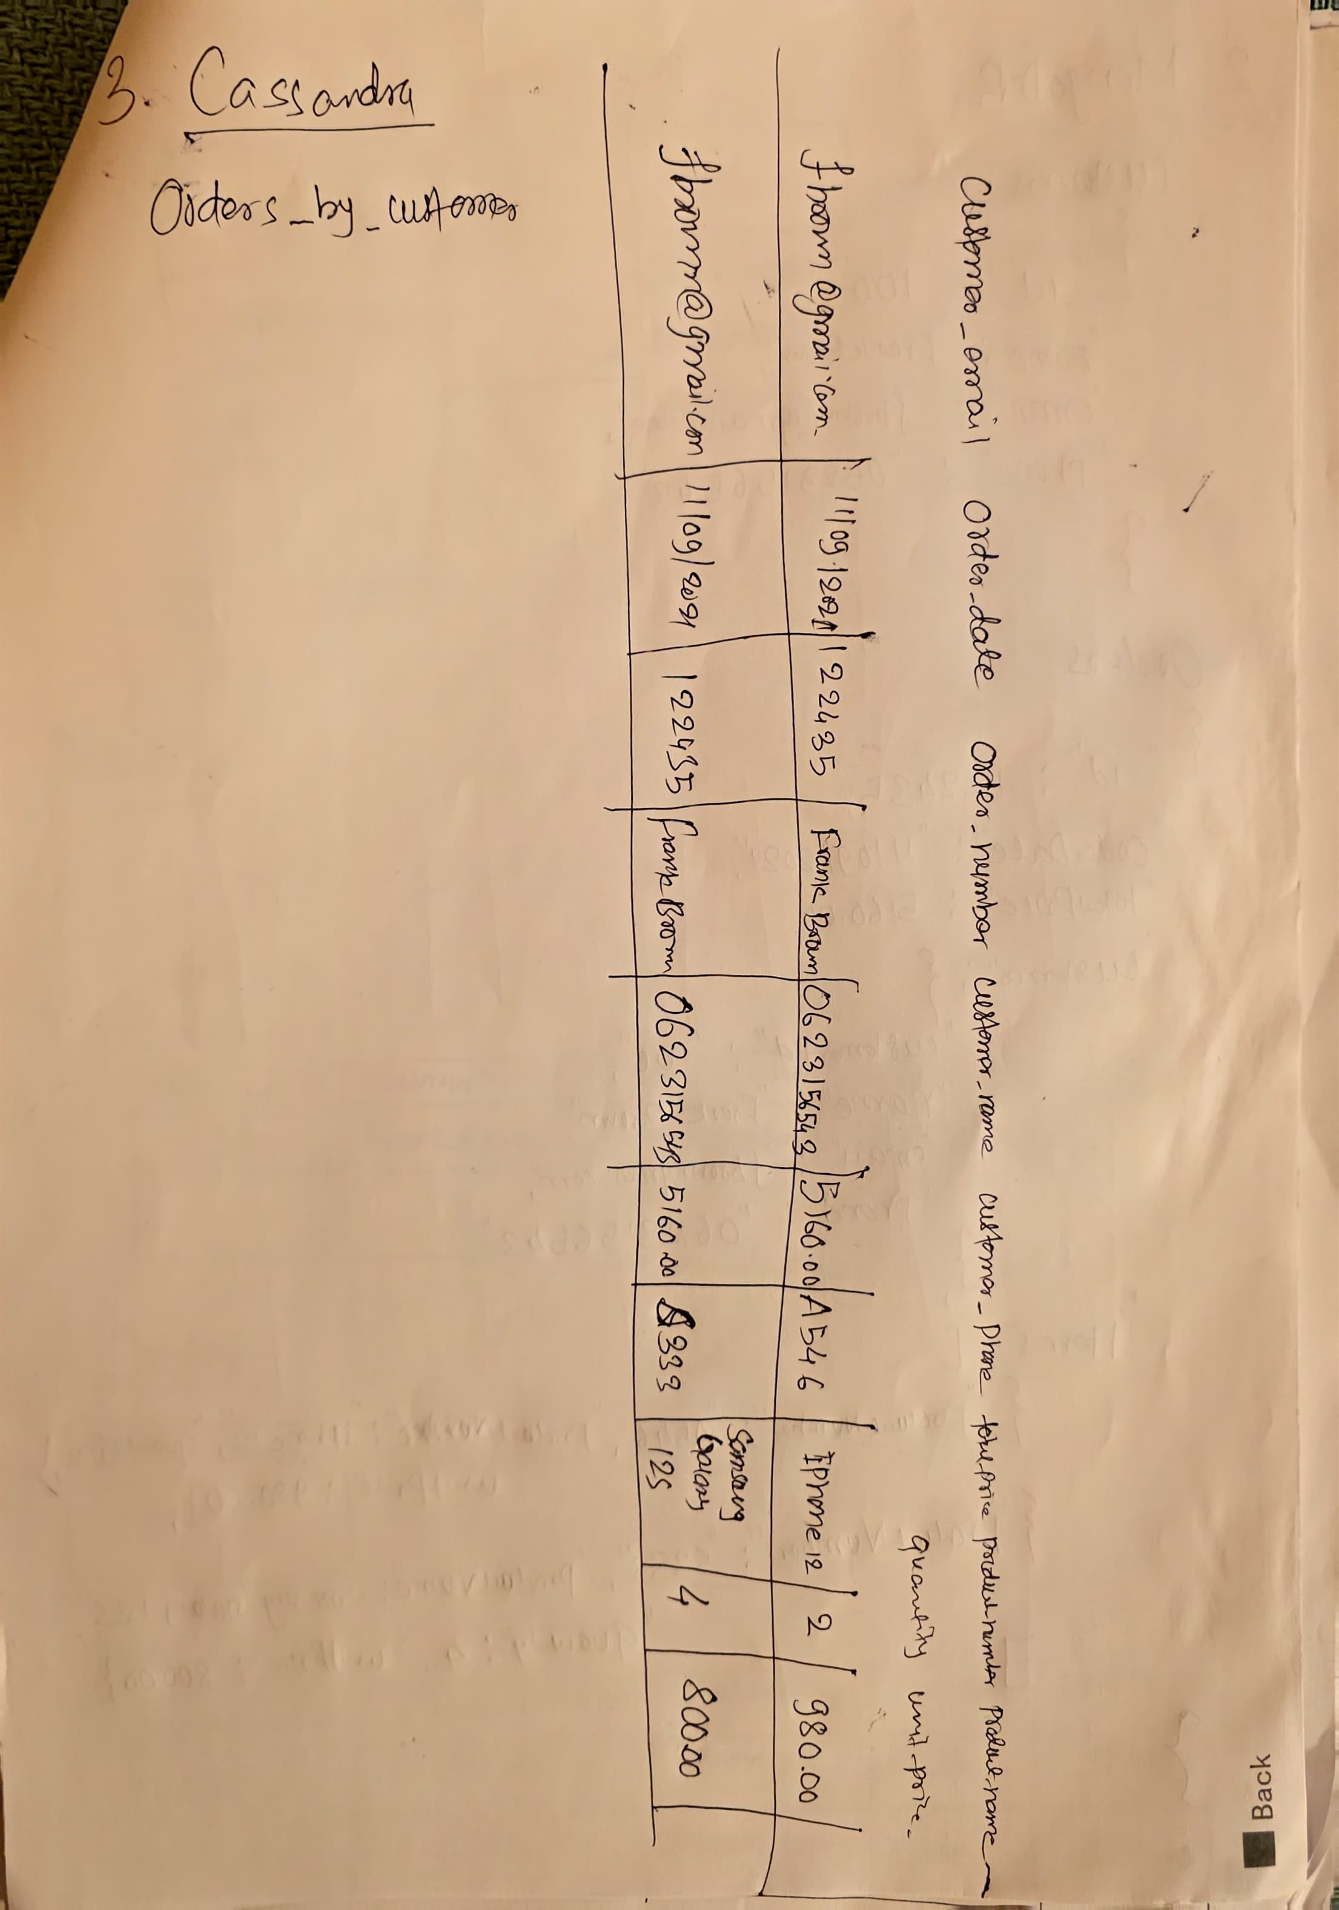

4. Draw the database structure including data that you need to store this order in a neo4j database.

